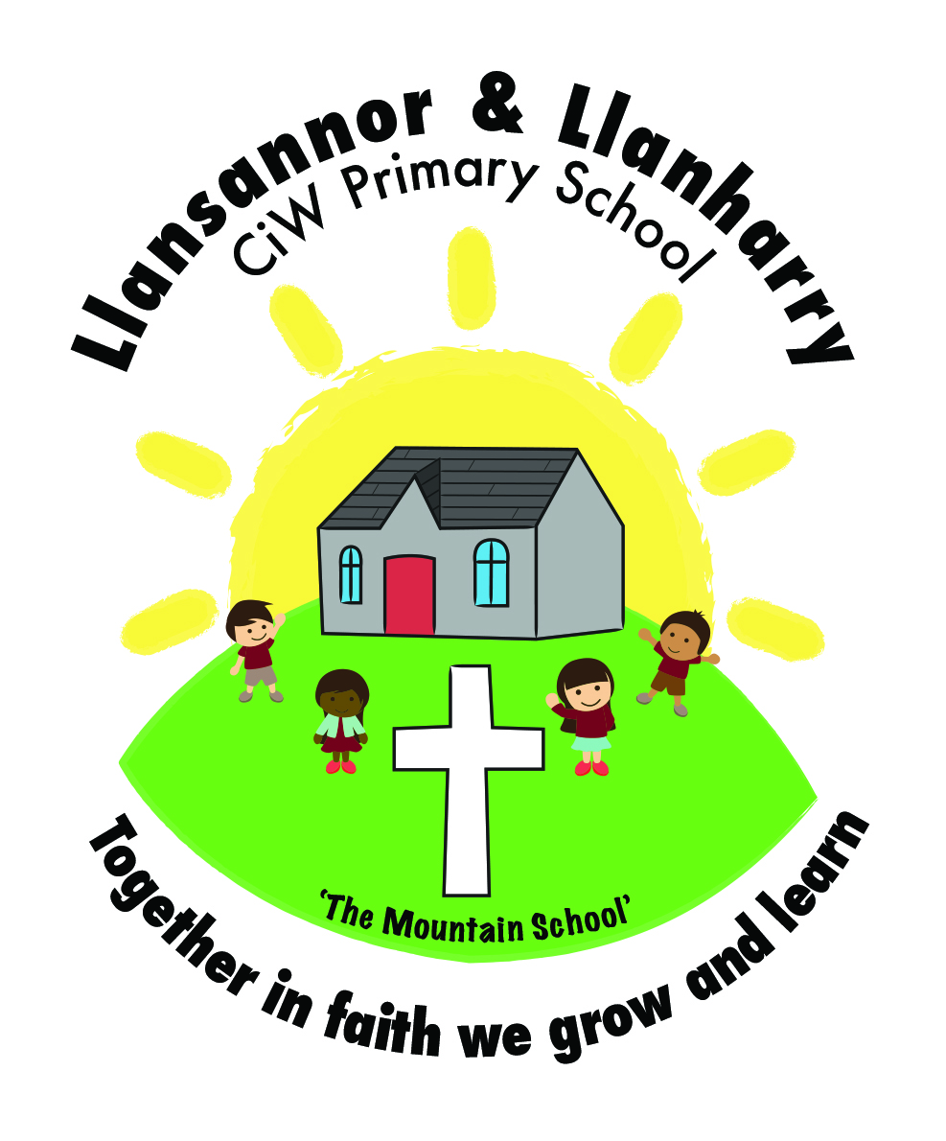
Llansannor CiW Primary School
Pupils’ Innovations and Creations Planning 2016-17

Topic: Tales and Scales

Spring Term 1

Key Skills | What would you like to learn? | Literacy  Focus | Numeracy Focus | ICT Focus
KUW – Time and People  communicates a developing sense of chronology by using terms concerned with the passing of time and by ordering events and objects. (FPO5)  aware that the past can be divided into different periods of time (FPO6)  makes distinctions between aspects of their own life and past times  (FPO5)  recognise some of the similarities and differences between different periods of the past(FPO6)  demonstrates knowledge of aspects of the past and of some of the main events and people they have studied (FPo5)  demonstrate knowledge of some of the main events, people and changes studied (FPo6)  starting to recognise that there are reasons why people in the past acted as they did.  (FPo5)  beginning to suggest a few reasons for, and results of, the main events and changes  (FPo6)  beginning to recognise that there are different ways of representing the past(FPo5)  identifies some of the different ways in which the past is represented.(FPo6)  asks questions about the past and finds answers by making simple observations from historical sources provided (FPO5)  suggests ways of using historical sources to answer his questions about the past(FPO6)  selects, organise and communicate items of information about the past.  (FPO6) | Learn about different castles in Wales. When were they built?  Which is the oldest castle in wales? Do we still build castles today? Research the different castles around wales. Which is the nearest castle to Llansannor?  What was it like to live in a castle?  Who lived in a castle?  Compare ways of life then and now. Look at castle life and what it would have been like. Compare the day in the life of a child with their own.  As above | Read information from sources.  Read information from sources and discuss. | Order the dates in which castles were built. | Use internet websites to find information.  ICT - Use the internet safely to search - Google images of castle

