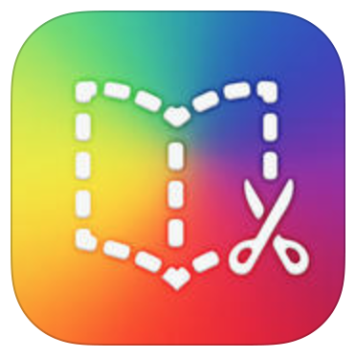

Working With iPads Workshop

26-01-2017

Book Creator Guide

* Open app
* Select the + symbol at the bottom of the screen.
* Choose ‘new book’
* Select desired size/format

**To input text**

* Select the + symbol at the top right hand corner
* Choose ‘add text’
* Use the keyboard to type text and press ‘done’

**To edit the text/enhance**

* Highlight the text by tapping once on the writing then press the  symbol.
* Options will be displayed to change the font/color/position and size.

**To add/import a picture**

* Select the + symbol at the top right hand corner
* Choose ‘photos’ – this will allow you to explore your photo library.
* Choose ‘Camera’ – this allows you to use your camera to capture a picture.

**To add/import a video**

* Select the + symbol at the top right hand corner
* Choose ‘photos’ and then videos.





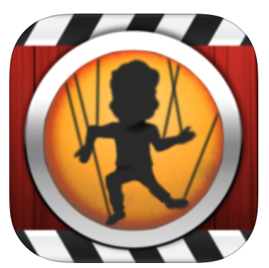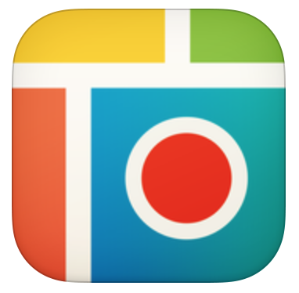

Puppet Pals Guide

* Open app
* Choose play

**Changing the Background/Scene**

* Tap on the chosen location you wish your scene to be set.
* If you choose ‘photos’ you add images from your library/camera.

**Adding a character**

* Select the character silhouette (located at the top left)
* Choose your characters.
* Move your characters around the screen

**Changing the Music**

* Select the musical note icon (located at the top left)
* Choose your favourite piece.

**Recording your scene**

* Practise moving your characters around with your finger.
* Rehearse your script.
* Select the record button (top right)
* Record your sequence
* When finished, press the stop icon.
* If you are happy with the recording, press the green tick. Alternatively, you can select the red cross to record again.
* Save your puppet pals movie.

**Saving your Movie**

* Go to the main menu of Puppet Pals 2
* Choose the video you have recorded.
* Select the square and arrow ‘share’ icon.
* Enter the passcode provided
* Choose selected quality and then press ‘save video’.

Pic Collage Guide

* Open app
* Choose new collage

**Changing the Background**

* Tap anywhere on the screen
* Choose purple background icon.
* Select your preferred colour
* Alternatively by selecting the magnifying glass icon, you can add an image from the web.

**Adding a Picture**

* Tap anywhere on the screen
* Choose green ‘photos’ icon (this will search your photo library)
* Choose blue ‘web images’ icon (this allows you to search Google images for a chosen picture)
* Type your chosen word into the search bar.
* Choose your image from the selection given and then press the ✓ (top right hand corner)
* Pinch/stretch to enlarge or shrink the image.

**Editing an Image**

* Double tap on the chosen image
* Choose from the selection of options – effects/boarder/scissors/set as background/copy)

**Adding Text**

* Tap anywhere on the screen
* Choose pink ‘text’ icon
* Type text and choose from a range of editing options.

**Saving**

* Select the ‘share’ icon (square and arrow)

