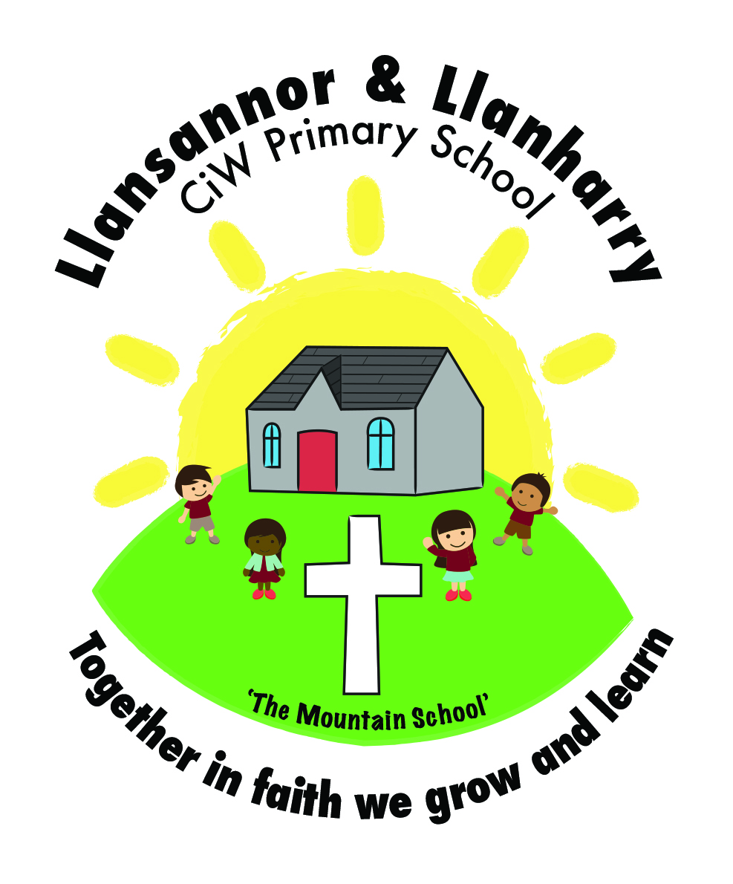
Year 2 Homework
09/03/2018

Please find a list of things to do for homework over the weekend. A copy of this letter and activities have been uploaded to the website.

Reading (10mins per night) – Please place a focus on discussing the story throughout the book to develop their comprehension and understanding of what they have read. Examples of what to discuss: what is happening? Why? Where is the story set? How do you know? How is the character feeling? Why? How do you know this? Can you find a word in the text to show this? Can you retell the part of the story when… and Can you find the word that means?

Literacy
Spelling – Plurals (dropping y to become -ies)Please have a go at spelling these words independently and then using them in a sentence.

baby – babies
bunny – bunnies
penny – pennies
diary – diaries
family - families

Can you make any more words plural?

Numeracy
Please complete the maths activities in the homework book.

Have a lovely weekend!

Mr Camilleri

Year 2 Homework
09/03/2018

Please find a list of things to do for homework over the weekend. A copy of this letter and activities have been uploaded to the website.

Reading (10mins per night) – Please place a focus on discussing the story throughout the book to develop their comprehension and understanding of what they have read. Examples of what to discuss: what is happening? Why? Where is the story set? How do you know? How is the character feeling? Why? How do you know this? Can you find a word in the text to show this? Can you retell the part of the story when… and Can you find the word that means?

Literacy
Spelling – adding ‘d’ or ‘ed’ to the ends of words. Please have a go at spelling these words independently and then using them in a sentence.

paint – painted
wave – waved
use – used
rain – rained
care – cared

Can you think of any more words that end in ed?

Numeracy
Please complete the maths activities in the homework book.

Have a lovely weekend!

Mr Camilleri

Year 2 Homework
09/03/2018

Please find a list of things to do for homework over the weekend. A copy of this letter and activities have been uploaded to the website.

Reading (10mins per night) – Please place a focus on discussing the story throughout the book to develop their comprehension and understanding of what they have read. Examples of what to discuss: what is happening? Why? Where is the story set? How do you know? How is the character feeling? Why? How do you know this? Can you find a word in the text to show this? Can you retell the part of the story when… and Can you find the word that means?

Literacy
Spelling – high frequency words. Please try and spell these words independently and then use them in a sentence.

then
was
said
all
want

Numeracy
Please complete the maths activities in the homework book.

Have a lovely weekend!

Mr Camilleri

