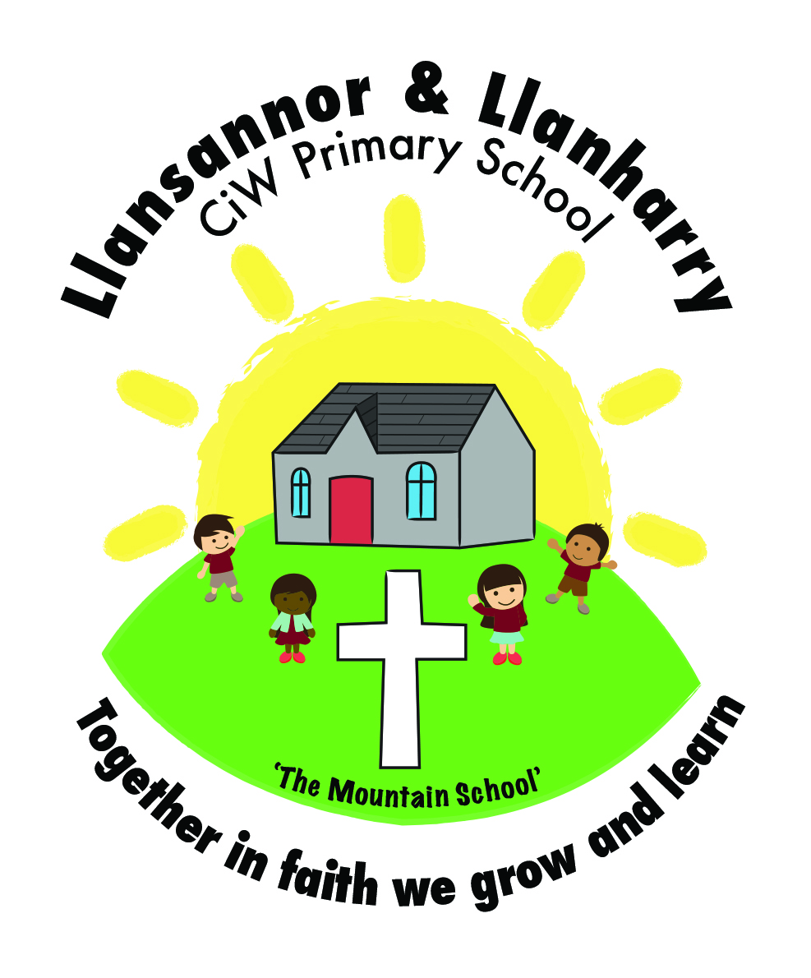

Llansannor CiW Primary School
Pupils’ Innovations and Creations Planning 2016-17

Topic: Scaly Tales

Spring Term 1

Key Skills | What and how would you like to learn? | Literacy  Focus | Numeracy Focus | ICT/DCF  Focus
Art and Design  Explores practically and imaginatively visual, tactile and sensory qualities.  (FPO5)  Experiments with visual, tactile and sensory qualities.  (FPO6)  Use a range of materials and tools to make images and artefacts.  (FPO5)  Uses a range of materials, tools and techniques to achieve different outcomes.  (FPO6)  Makes images from observation, experience, memory, ideas and imagination.  (FPO5)  Records ideas and feelings through drawing and other methods.  (FPO6)  Uses resources that they have collected and organised to support their work.  (FPO5)  When making images and artefacts, they can choose from a range of resources that they have collected and organised as a basis for their work.  (FPO6)  Makes changes to their work where they think they are necessary.  (FPO5)  Makes suitable changes to their work where they identify the need for modification.  (FPO6)  Recognises similarities and differences between their own practical work and that of others.  (FPO5)  Describes similarities and differences between their own work and that of others.  (FPO6)  Music  Keeps broadly in tune when singing songs comprising a limited range of notes.  (FPO5)  Sings songs in tune.  (FPO6)  Plays simple patterns on a percussion instrument in time to a steady beat.  (FPO5)  Can play an instrumental part using a limited range of notes.  (FPO6)  Controls their breathing in order to enhance her performance.  (FPO6)  They Choose and organise sounds in response to a given stimulus and create short melodic patterns, showing some control of musical elements.  (FPO5)  They work with others to create compositions that have a simple musical shape.  (FPO6)  They revise their ideas where necessary.  (FPO6)  They make broad distinctions within musical elements and use simple terms to describe how they are used for expressive purposes.  (FPO5)  They make distinctions within musical elements and discuss how effectively these elements are used.  (FPO6)  Creative Movement  They express their ideas and feelings through more varied movements.  (FPO4)  They communicate ideas, moods and feelings clearly to a partner or group through dance.  (FPO5)  They respond to varied stimuli, including a partner.  (FPO6)  They include different shapes, rhythms, and forms of travel in their movements, and make use of different parts of their body, moments of stillness and held balances.  (FPO4)  They move with increasing control, and show increasing awareness of the space away from others in which they can move safely.  (FPO4)  They improve their skills so that their actions have a clearer shape.  (FPO5)  They are beginning to show coordination, fluency and control through improved tension in their movements.  (FPO6)  They are starting to link and repeat simple movement phrases.  (FPO5)  They repeat patterned movements to be found in traditional dances with some accuracy.  (FPO6)  They plan simple movement patterns.  (FPO6) | Create a 3D egg including scales – use different media.  Make a 3D castle using junk materials and decorate. Design what it will look like and choose appropriate materials. Look at existing castles and base designs around them.  Sculpt a dragon using clay/plastacine.  Observe dragons and other reptile pictures and draw them from observation.  Use various materials and media to draw castles from around the world. Pupils decide on which media they use for specific castles.  Design a new type of dragon from children’s imaginations. Decide what type of dragon it will be and decide what that dragon would need to survive – wings/sharp teeth/gills etc.  Draw from observation – castles.  After reflecting on their own and others pieces of work, children make changes to their own work.  Children look at their own work and work of their peers to find similarities and differences. After studying the work of Martyn Evans, children compare their work to his.  Children look at their own work and the work of other pupils/Martyn Evans and describe the differences and similarities. Children to comment on their feelings for his/their pieces of work and compare to their own. Why do they think he/they chose to do something in a certain way?  Learn new welsh songs.  Learn songs about dragons.  Pupils learn the songs and learn to sing with clear diction and take note of breathing.  Pupils learn the correct melodies to welsh songs. Children sing with clear diction. Pupils learn and sing songs by welsh artists.  Children compose a piece of music for a dragon. Children use melodic percussion instruments to create their piece in pairs. Pupils to use two beaters.  Pupils choose on musical elements to include.  As above – children set their compositions to still frames and represent through graphic score.  Children listen back to their pieces and refine.  Children listen to the musical scores to dragon heart/how to train a dragon. Children describe how the music makes them feels, why the composer chose to sounds/instruments/specific musical elements.  Children listen to specific scores and identify various musical elements. Children discuss why they have been used. | Write about out models and what we think of them. Talk about other models and compare to real castles.  Write instructions to make the dragon.  Describe what the dragon looks like and why he looks like that. Descriptive writing.  Pupils write evaluations of their work and suggest similarities and differences between their work and the work of others.  Reading lyrics and discus their meaning.  Pupils discus their musical ideas with their partners/ groups.  Children listen to ideas and suggestions from peers.  Pupils write an appraisal of their own work/ appraisal of work by other composers. | Measure the height in cm/mm/m  When listening to the scores, children find specific timings within the pieces. Minutes and seconds. | Use ICT to find images of castle features and use to decorate.  Animate the model dragon.  Pupils use the internet to research the work of Martyn Evans.  Pupils type their evaluations.  Pupils contact Martyn Evans through email to ask questions on his life and work .  Children use ICT equipment to choose and listen to welsh songs.  Children use garage band to create simple sounds.  Children record their work.  Pupils record their work and listen back.  Pupils listen to work by other musicians/  composers.

