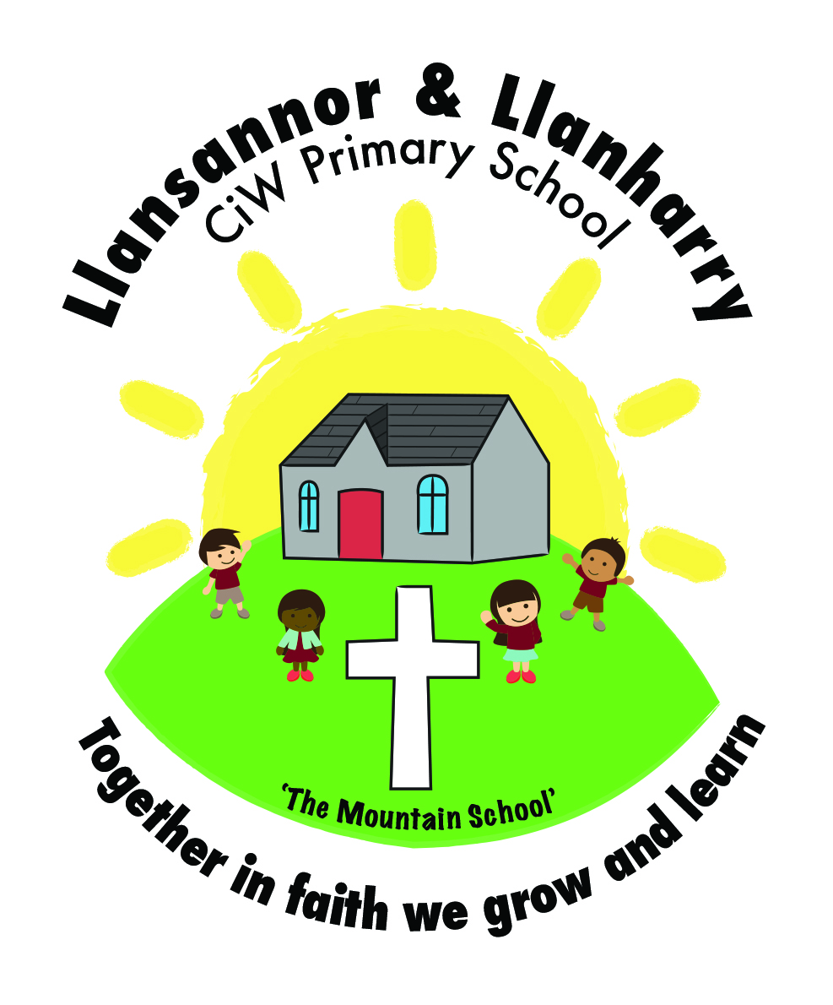
Year 2 Homework
16/02/2018

We have had another busy half term in Year 2. We have learnt about healthy and unhealthy food, how food travels through our body, multiplication and division.

Please find a list of things to do for homework over the half term holiday. A copy of this letter and activities have been uploaded to the website.

Reading (10mins per night) – Please place a focus on discussing the story throughout the book to develop their comprehension and understanding of what they have read. Examples of what to discuss: what is happening? Why? Where is the story set? How do you know? How is the character feeling? Why? How do you know this? Can you find a word in the text to show this? Can you retell the part of the story when… and Can you find the word that means?

Literacy
When we come back to school, the children will be delivering a short presentation to their group. Over the half term holiday, we would like your child to put together the presentation, which should be based on food. The children can present this in any way they like. It may be a PowerPoint presentation, photographs, pictures or presented on a board of some type. The presentation shouldn’t be any longer than 5 minutes. We would encourage the children to not write too much and read from the presentation. We would like to see them talk to their group naturally.

Numeracy
Please complete the maths activities in the homework book.

Have a lovely holiday.

Mr Camilleri

