Friday 12th October 2017
Dear Parents or Guardians,

RE: HWB Homework
For homework this week, we would like the children to complete one of the activities below and save it using HWB. Children having been using it this week in school and have been shown how to save and retrieve their work. Instructions have been attached to this letter. A few of the pupils are still having difficulty signing in to HWB due to password problems. Once these have been reissued by HWB, I will send these home next week. If you are unable to access HWB then please complete the following using ipads or Microsoft Word instead. Apologies in advance.
Activity
Option 1 - Enjoy an Autumn walk in your local area. Take photos of the walk and upload to HWB.
Or
Option 2 - Use the J2e5 tool on HWB to write an autumn description. Remember to use adjectives, adverbs and adverbial phrases. Can you describe what you can see, hear, feel and touch? How is it making you feel? Challenge: Use paragraphs and commas accurately.

Kind Regards,
Mrs Stuart

Please have a go at home!

Step 1 – Log on to HWB https://hwb.wales.gov.uk

Step 2 – Log in using the unique username and password (This was sent last week).

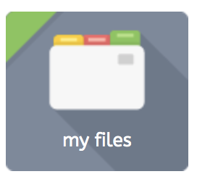
Step 3 - Once logged in, choose from the options along the left-hand side of the page and select j2e (Just 2 easy). This will then take you to the J2 launch pad.

Homework Option 1 – Choose the ‘my files’ icon.

Once you have accessed you file, drag and drop the autumn photos in to the box:
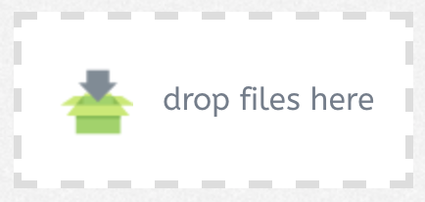

Photo’s will be automatically saved in the file.
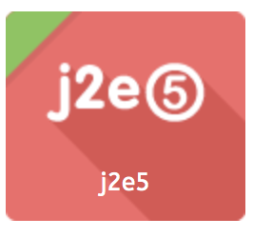

Homework Option 2 – Choose the J2e5 icon.

Once you have accessed the J2e5 package, click anywhere on the screen to start writing on the interactive paper. It should look like this:

Once completed, click the save button.

This will be saved into their pupil file.

If you should experience any problems with HWB or have any queries, please let me know during our parents evening appointment next week. Many thanks, Mrs Stuart

