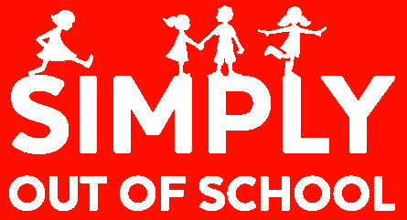
LLANSANNOR

AFTER SCHOOL club

- All children between 3 and 11 years of age welcome.
- fULLY QUALIFIED AND EXPERIENCED STAFF

AT: LLANSANNOR PRIMARY SCHOOL

Our AFTER SCHOOL CLUB opened September 2015. Children will be collected from school by our qualified staff and escorted to the nursery/reception building. A register will be taken to ensure all children expected are present and they will be safely escorted to the hall.

- Opening hours: school finish – 5.30pm.
- A snack will be provided at 4pm which will consist of fruit, toast crackers etc. Drinks will be available at all times. ALL INCLUDED IN THE PRICE.
- Any individual Dietary needs will be catered for at no extra cost.
- Children with Special Needs are catered for.
- DISCOUNTS for siblings: 5%

WHAT’S AVAILABLE FOR THE CHILDREN

Lots of fun and games … variety of board games, toys suitable for all ages, topical or themed activities, arts and crafts / cookery, dancing, structured games, television, DVD, PlayStation/Wii, quiet corner, help with homework, listening to reading, etc.

After school club fees: £8.25 per child per session paid monthly in advance.
Sibling discount 5%.

There is a £15.00 annual registration fee per child.

For more information or to book your child’s place, please call us on 07860 279863 or email laura@simplyoutofschool.co.uk

